Academic Year: 2025-26 | Year: Second Year | Semester: II
PRN No.: 1012411011 | Name: Riddhee Kulkarni
Subject: Python Programming
Assignment No.: 7
Date: 05/01/2026

Lab Assignment: 07
Aim:
To write a Python program to calculate the roots of a quadratic equation.

Objective:
To accept coefficients of a quadratic equation and compute its roots using the discriminant method.

Theory:
A quadratic equation is of the form
ax^2+bx+c=0
The nature of roots depends on the discriminant
D=b^2−4ac
- If D>0: Two distinct real roots
- If D=0: One real root
- If D<0: No real roots

Algorithm:
- Start
- Read values of a, b, and c
- Calculate discriminant
- If D > 0, calculate roots
- Elif D=0, calculate roots
- Else, display no real roots
- Stop

Pseudo Code:
START
READ a, b, c
D = b*b - 4*a*c
IF D > 0
r1 = (-b + sqrt(D)) / (2*a)
r2 = (-b - sqrt(D)) / (2*a)
PRINT r1, r2
ELIF
r1 = (-b + sqrt(D)) / (2*a)
r2 = (-b - sqrt(D)) / (2*a)
PRINT r1, r2
ELSE
PRINT "No real roots"
END IF
STOP

Code:
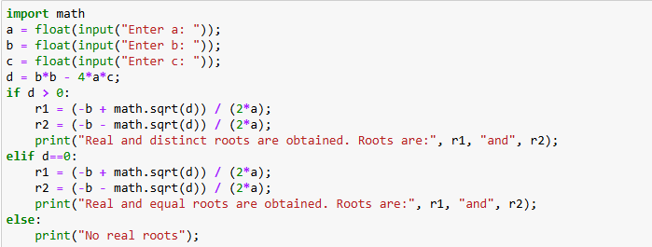

Output:
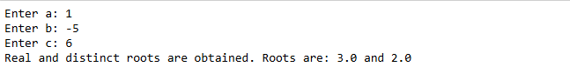
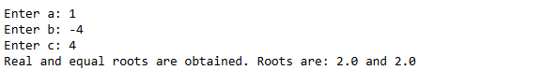
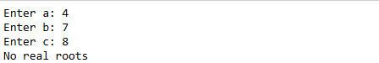

Conclusion:
The program successfully calculates the roots of a quadratic equation based on the discriminant value.

